Button How To

Use Imagemajik (download from open source project)

Pick Icon files from BlizzardInterfaceArt Files. (you will need to redownload from PTR/Beta each release to get any new icons they add, i.e. again at 8.1)

icons created by using BLP2PNG (google it, download it.)

the source is blizzard art file.

http://wowwiki.wikia.com/wiki/Extracting_interface_file

after extracting the icons you want, save them in the wowpro utilities directory.

Icons are found in the icon directory. File names can be found by looking on wowhead (or you can just search and randomly click on ones you like the name of…) if you can’t find icon in the icon directory that wowhead lists, it is time to get a new blizzard art file.

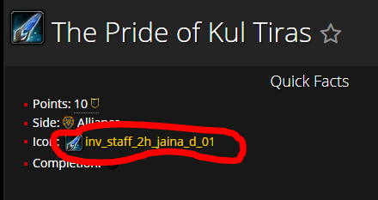

Drag them over and drop them on the blp2png.exe file and it will convert to png files

Move the newly created file to the WoWpro Utilities Directory

Faction symbol, font and background found in the WowPro_Utilities directory

The actual mechanics, now that the tools are assembled.

Use Bash (type bash from windows command prompt to open bash shell.)

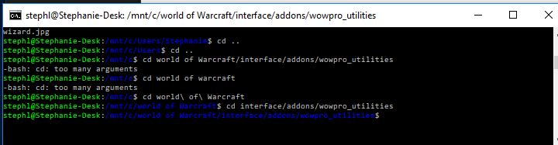

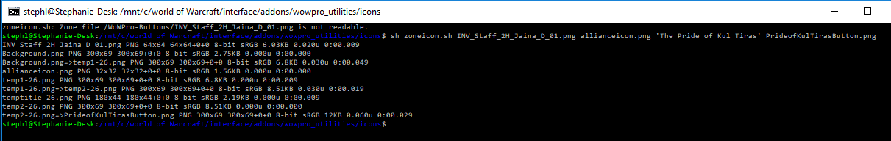

sh zoneicon.sh <name of icon file> <factionicon.png> <’guide name’> <output filename>

i.e. like this

sh zoneicon.sh /achievement_DoublejeopardyAlly.png allianceicon.png ‘War Campaign’ Button/WarCampaignButtonA.png

if you want to force the name to break at a specific point use \n ( ie ‘The Pride of\nKul Tiras’)

upload the icons to the wowpro website on the wiki you want to use them on and then reference them on the page. Let Ludo know so he can get them into the wp utilities directory on github. (may not be necessary. Need to check with him, if that is automated)

I have this file, the blizzard art files and the blp to bmp program at c:\WP-Buttons.

The reason this directory exists is because I delete the wowpro utilities directory every time I update, and I don’t want to redownload bliz art file or lose this document, and I don’t want to have to remember to save those things out each time. (and the art file is huge!)